Service Functional Description:

The objective of InsuranceDataProcessing Service is to create New Business, and convert or update the existing business, “Master Data” information to establish a billing account into the Provider application. The “Master Data” information, which governs the behavior of the financial transactions related to the Insured, their accounts, and their policies This service covers the Farmer’s business sub-process functions such as Quotes, Issue New Business, New Business, Re-writes and Renewals.

InsuranceDataProcessingService WSDL signature:

<xsd:complexType name="EstablishInsuranceBillingDetailsRequest">
<xsd:sequence minOccurs="0" maxOccurs="1">
<xsd:element name="requestHeader" type="ZSOA:RequestHeader"/>
<xsd:element name="businessPartners" type="ZSOA_Party:BusinessPartner" minOccurs="0" maxOccurs="unbounded"/>
<xsd:element name="businessTranasctionRequestDetails" type="ZSOA_Common:ApplicationContext"/>
<xsd:element name="contractAccounts" type="ZSOA_FinancialServicesAgreement:ContractAccount" minOccurs="0" maxOccurs="unbounded"/>
<xsd:element name="insuranceObjects" type="ZSOA_FinancialServicesAgreement:InsuranceObject" minOccurs="0" maxOccurs="unbounded"/>
</xsd:sequence>
</xsd:complexType>
<xsd:element name="EstablishInsuranceBillingDetailsRequest" type="ZSOA_WS:EstablishInsuranceBillingDetailsRequest"/>
<xsd:complexType name="EstablishInsuranceBillingDetailsResponse">
<xsd:sequence minOccurs="0" maxOccurs="1">
<xsd:element name="responseHeader" type="ZSOA:ResponseHeader"/>
<xsd:element name="businessTransactionResponseDetails" type="ZSOA_Common:BusinessTransactionDetails"/>
</xsd:sequence>
</xsd:complexType>
<xsd:element name="EstablishInsuranceBillingDetailsResponse" type="ZSOA_WS:EstablishInsuranceBillingDetailsResponse"/>

<!-- end of TYPES REQUIRED FOR PARAMETERS -->
</xsd:schema>
</types>

<!-- SERVICE BLOCKS -->

<service name="InsuranceDataProcessingService">
<port name="InsuranceDataProcessingSOAPPort" binding="ZSOA_WS:InsuranceDataProcessingSOAPBinding">
<soap:address location="http://www.ibm.com/services/fsidm/IInsuranceDataProcessing.asmx"/>
</port>
</service>
<!-- end of SERVICE BLOCKS -->

Service Signature BOTs:
Business Partner (Party)

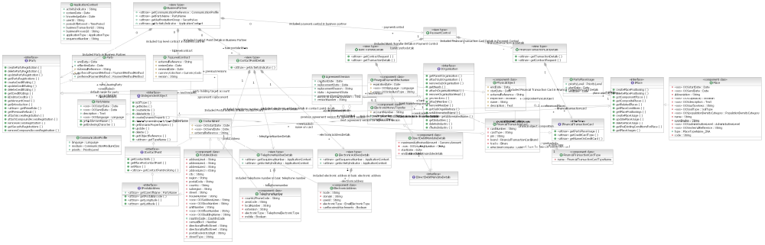

Contract Account (Customer Account Agreement)

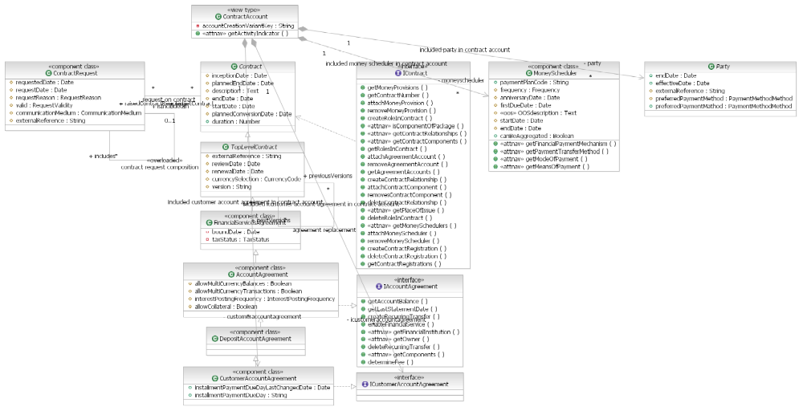

InsuranceObject (Financial Services Agreement)

